

Project Initialization and Planning Phase

Date | 23 June 2026
Team ID | SWTID-2026-7169
Project Name | OptiCrop: Smart Agricultural Production  Optimization Engine
Maximum Marks | 3 Marks

Define Problem Statements (Customer Problem Statement Template):

Create a problem statement to understand your customer's point of view. The Customer Problem Statement template helps you focus on what matters to create experiences people will love. A well-articulated customer problem statement allows you and your team to find the ideal solution for your customers' challenges.
Throughout the process, you’ll also be able to empathize with your customers, which helps you better understand how they perceive your product or service.
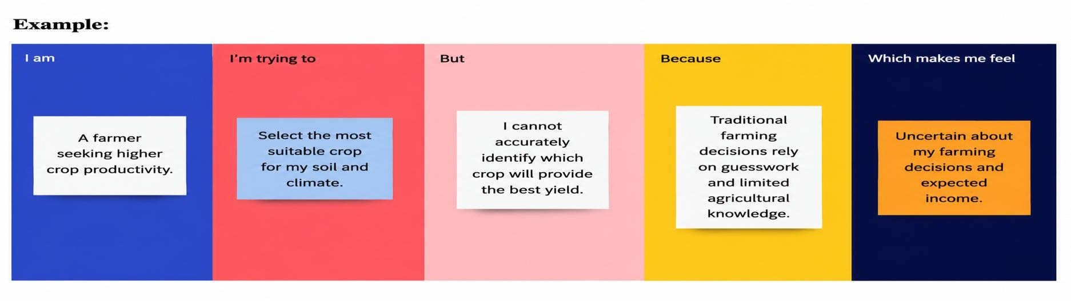

Problem Statement (PS) | I am (Customer) | I'm trying to | But | Because | Which makes me feel
PS-1 | A farmer seeking higher crop productivity. | Select the most suitable crop for my soil and climate. | I cannot  accurately identify which crop will  provide the best yield. | Traditional farming  decisions rely on guesswork and limited agricultural  knowledge. | Uncertain about my farming  decisions and  expected income.

